Donor Report: Cover Letter Template
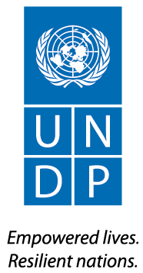

Ref: UNDP/[xxx]/[xxx]/[xxx]
2025
Dear United State Agency for International Development,

Subject: Project “Iraq Crisis Response and Resilience Program – Environmental Resilience”
Final Report

Reference is made to the contribution agreement between USAID and UNDP for the project “ICRRP-ER” effective March 2023.

I am pleased to submit herewith the Final Report for the abovementioned project.

The report summarises the project's progress as of 31st Dec 2024 and provides an overview of the achievements, challenges, lessons learned, interim financial status, and way forward.

I thank USAID and the United State mission in Iraq for its contributions to UNDP and look forward to strengthening our partnership in support of development in Iraq.

Auke Lootsma
Resident Representative
UNDP Iraq

Attached:
ICRRP-ER Final Report

Zachary Clarke
CONTRACTING/GRANT OFFICER
USAID
.

Final Report

United Nations Development Programme
Iraq

00085156 Iraq Crisis Response Resilience Programme (ICRRP) – Environmental resilience-UNDP-IRQ-00133642
June 2025

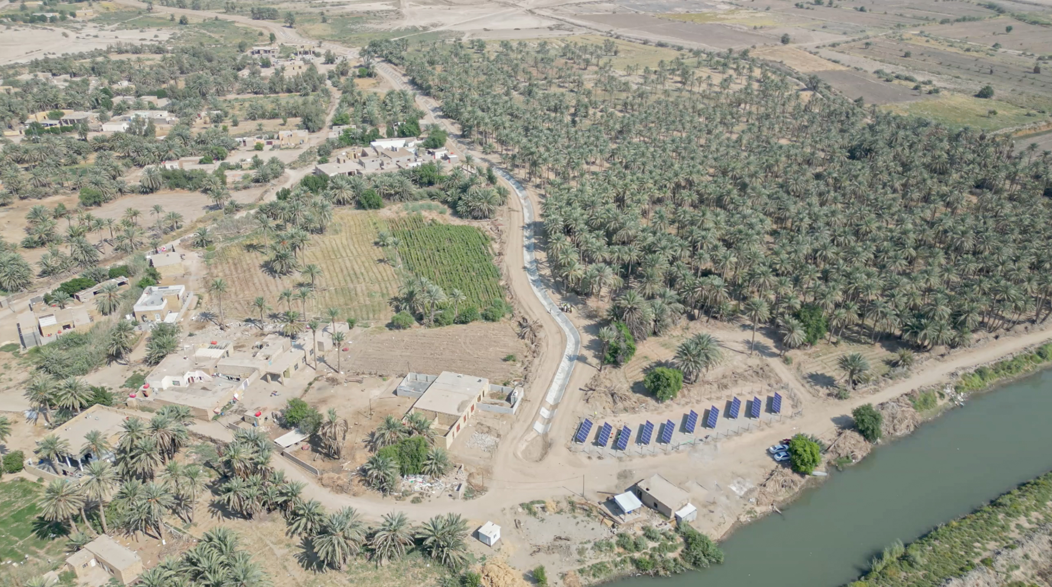t of the programme/project.

Al-Muthanna Governorate – Najmi District – Aksha Water Canal (Canal feeding over 2700 dunums, with beneficiaries exceeding 546 farmers (directly and indirectly) Solarized and paved (1.67 KM) through the ICRRP-ER project .
Picture taken Oct 2024 - UNDP IRQ
Reporting Period | 12/03/2023 -31/12/ 2024
Donor | USAID
Country | Iraq
Project Title | 00085156 Iraq Crisis Response Resilience Programme (ICRRP) - Environmental resilience-UNDP-IRQ-00133642
Project ID | 00133642
Outputs (Project ID and Description) | Iraq Crisis Response Resilience Programme (ICRRP) - Environmental resilience-UNDP-IRQ-00133642
Strategic Plan and/or CPD Outcomes | CPD Outcome (2020-2024): 4.1. Strengthened and resourced policies and frameworks are implemented for managing natural resources (including transboundary issues), developing renewable resources, and increasing resilience to climate change, environmental stress and natural hazards, and human-induced and natural disasters.  CPD Output 4.1. National capacities improved for climate change adaptation and mitigation.  Output 4.2. Disaster risk management and resilience strengthened with multi-stakeholder engagement, in geographic locations at high risk of human-induced or natural disasters.
Implementing Partner(s) | UNDP-IRQ
Project Start Date | 18/Oct/2022
Project End Date | 31/12/ 2024
Total resources required (total project budget) | USD 4,250,000.00
Revenue/Resources received
  Funding source/donor | Amount received (USD) | Expenditure
  4,250,000.00 | 4,250,000.00 | 3,869,061.62
Unfunded budget | Not Applicable
UNDP Contact Person | Auke Lootsma  Resident Representative  UNDP Iraq  Email: auke.lootsma@undp.org  Tel.: +964 (0) 783 780 1987
Table of Content

1. Executive summary 3
2. Background 4
3. Challenges and Mitigation Measures 5
4. Progress Review. The latest approved AWP can be attached as an Annex. 6
4.1 Progress towards CPD/ UNSDF Outcome 6
4.2 Progress towards relevant CPD Outputs 7
4.3 Progress towards PROJECT OUTPUTS 7
Accumulative Progress Update: 10
4.4 Human Interest Story 16
5. Cross-cutting issues 18
5.1 Gender results 18
5.2 Partnerships 18
5.3 Environmental Considerations 19
6. Project risks and issues 20
6.1 Project risks and challenges 20
7. Lessons Learned 22
8. Conclusions and Way Forward 25
9. Financial Status 26
Annex 1 Farms Criteria: 27
Annex 2 USAID Project Indicators: 28

Executive summary
The project aimed to assist farmers by providing clean and sustainable irrigation systems powered by photovoltaic (PV) technology. These components were supported by the USAID with the technical assistance and implementation of the UNDP, in the mid and south of Iraq, which are considered more climate vulnerable as in the governorates (Babil, Najaf, Karbala, Wasit, Qadisiya, Muthanna, Maysan, Dhi Qar and Basra). More than 830 farmers were targeted with the supplied services.
Under CPD (2020-2024), Output 4.1, the project significantly advanced national capacities for climate change adaptation and mitigation by deploying 120 renewable energy systems—including 116 solar irrigation units and four medium-scale solar systems—across vulnerable regions in Iraq. These systems enhanced energy access, reduced emissions, and promoted climate-resilient agriculture. In parallel, Output 4.2 strengthened disaster risk management and resilience through broad multi-stakeholder engagement, involving over 30 local institutions, nine Water User Associations, and more than 50 private sector entities. This collaborative approach ensured inclusive, accountable, and transparent implementation, particularly in high-risk areas such as Al-Muthanna, where shared water resources were managed through conflict-sensitive local coordination mechanisms.
The key achievements:
- 116 Solar Systems were supplied, installed, and fully operational, in 8 governorates, benefiting 696 farmers.
- 77 Sprinkler Systems with full connection supplied, installed, and fully operational in 8 governorates.
- 60 Pumps have been supplied, installed and fully operational, in 7 governorates.
- 2 Land Laser Levelers devices have been delivered to Water Directorates in Both Basra and Muthanna Governorates, with the appropriate training to operate, benefiting no less than 40 farms per season.
- Solarized screens in 2 public spaces with the expanded exposure to raise awareness on climate issues and climate efforts.
- Capacity building for 152 youth (male and female) on renewable energy, and advanced business skills training for 50 SMEs.
- Rehabilitation of Water Canal in Al-Muthanna governorate (Aksha District), directly benefiting 174 farmers, and indirectly benefiting 372 farmers.
Mapped to address specific on-the-ground needs, such as in Karbala, the strategy focused on deploying closed-pipe irrigation systems to mitigate water loss attributed to evaporation and leaks. In Basra and Al-Muthanna, the introduction of Laser Levelling devices proved pivotal in optimizing water use efficiency, enhancing crop establishment, reducing irrigation duration, and streamlining water management. These devices ensure precise land levelling, diminish weed proliferation, promote uniform crop maturity, and expedite task completion. Moreover, they reduce water requirements and streamline land preparation, mitigating soil degradation and loss of productive land.
However, it encountered significant challenges from fluctuating water rationing, complicated multi-ministerial coordination, and delays in procurement and site identification.
One of the most delayed steps was finalizing beneficiary lists (farms) as it required heavy and prolonged legal endorsements from both the Ministry of Agriculture and the Ministry of Water Resources.
Additionally, USAID’s restriction on funding public buildings has further imposed delays and shift and complicated implementations.
Procurement was prolonged due to stringent technical specifications to ensure quality solar systems suited for Iraq’s conditions.
To address these obstacles, the project developed a comprehensive beneficiary selection framework and shifted focus to private and charitable-owned buildings for solar installations. Through continuous coordination with government partners, strategic engagement with USAID, and technical verifications by engineers, the project-maintained progress and delivered sustainable clean energy solutions aligned with national climate and development goals.
The project’s innovative approach extends beyond technological advancements to encompass a full cycle of sustainable agriculture and food production. This includes solar systems, solar pumps, sprinkler systems, and laser land levelling devices, paired with capacity-building initiatives. Any omission in this chain would profoundly impact the project’s outcomes.
The project has also attracted attention from governmental authorities, sparking conversations around upscaling. Co-financing opportunities such as the Green Climate Fund (GCF), ETAF from IRENA, the Central Bank of Iraq’s solar initiative, and the USD 60 million government plan for solarizing public buildings indicate momentum and commitment for future investments. The project aligns with Iraq’s development agenda—addressing displacement, climate change, land degradation, and local economic revitalization—and contributes to international frameworks promoting inclusive recovery and access to essential services.
GCF funded projects is being deployed now in Iraq with the implementation of different UN agencies, targeting Solarizing Agriculture sector in Iraq, and food security, of no less than 39,000,000.00 USD.
Efforts are undertaking on the SLOANs for solarizing households and small to medium sized businesses
The implementation of Output 3 of the ICRRP revealed that integrated planning, early stakeholder engagement, and government ownership are essential for navigating complex, multi-sector projects in Iraq. Tailored technical solutions, such as solar-powered irrigation and canal rehabilitation, proved more effective when adapted to local environmental and socio-economic conditions. Community involvement and site-specific piloting enhanced sustainability, while clean energy interventions significantly improved rural livelihoods through cost savings and productivity gains. Challenges related to procurement, conflict, and communication were addressed through early planning, donor coordination, and local mediation. Lastly, youth and MSME capacity-building efforts highlighted the need for long-term support, financing, and market access to ensure lasting impact.
Total budget allocated to achieve this output 4,250,000.00 USD, and the project was able to utilize 3,783,915.76 USD through the implementation period. The project sought an extension of 6 months beyond Dec 2024, and It was aligned, and not opposed by the technical focal points from the donor side, but later was eradicated due the termination of the project by the donor in compliance with the US Executive Order of the International Aid Termination on the 20th of Jan 2025.
Financial Overview as of 31 Dec 2024 (USD)
Total Received Amount | Expenditures | Obligation | Balance
4,250,000.00 | 3,783,915.76 | 248,917.21 | 217,167.03

The remaining obligated amount (248,917.21) under one of the components of the output was still to be released after the finalizing of the work related to it (Aksha water canal), as the implementation is not fully completed.
A remaining balance under the output, was to be utilized to increase the number of beneficiaries, under No Cost Extension to the output three under the OAR/USAID approval, which was preceded by the US Executive Order of the International Aid Termination on the 20th of Jan 2025.

Background
Under Output 3 of the Iraq Crisis Response and Resilience Programme (ICRRP), the cooperation between USAID and UNDP set out to enhance clean energy solutions, environmental resilience, and market-based services across Iraq. This initiative was launched at a time when Iraq was facing the compounded impacts of climate change, land degradation, and a chronic energy crisis. Iraq’s national grid suffers from a 30–50% electricity supply gap, resulting in 60% of the population living in energy poverty. Although generation capacity increased by one-third in recent years, peak demand continues to outstrip supply, especially in rural and remote areas, leaving low-income farmers to suffer prolonged power outages and a lack of grid connectivity.
This project is closely aligned with Iraq’s National Climate Change Policy and its Nationally Determined Contributions (NDC), serving as a practical implementation of the country's priorities for climate adaptation and mitigation. By promoting renewable energy solutions—particularly solar-powered irrigation—and advancing sustainable water and land management practices, the initiative directly supports Iraq’s strategic objectives to reduce greenhouse gas emissions, enhance resilience in vulnerable agricultural areas, and transition toward low-carbon development. It also reflects the government’s commitment to integrating climate action into national development planning and improving energy access for underserved rural communities.
Also, this project fits in great alignment with the Global SDG Targets 2030, particularly SDG 7 (Affordable and Clean Energy), SDG 13 (Climate Action), and SDG 2 (Zero Hunger). By deploying solar-powered irrigation systems and promoting efficient water use, the project advances access to clean, renewable energy while enhancing agricultural productivity and food security in climate-vulnerable regions. It also contributes to SDG 6 (Clean Water and Sanitation) by improving irrigation infrastructure and reducing water losses, and SDG 8 (Decent Work and Economic Growth) through capacity-building and support to youth and MSMEs in the renewable energy sector. The integrated, community-based approach reinforces inclusive, resilient, and sustainable development across multiple dimensions.
Lack of power supply has a crippling effect upon productivity of farmlands and livelihoods of farmers. The farmers for example face challenges in irrigating the fields and conducting farm-based activities, such as harvesting, storage of fruits and vegetables and livestock rearing. This results in loss of opportunity and income for farmers. In the absence of grid connectivity, farmers usually resort to diesel generators for irrigation and other farm activities, which increases the cost of production. Many small farmers however can’t afford generators. Furthermore, generators also have recuring costs related to diesel supply, maintenance, and replacement of batteries etc. Therefore, the costs of production and farm management remain high for the farmers and the produce low.
Comparison of cost of fossil fuel and PV powered 1MW Irrigation System for 3 Years
Parameter | Unit | Cost of Fossil Fuel based System | Cost of PV Powered System
Generator capacity | 1 Megawatt
Installation Cost | 1 Set | $ 150,000.00 | $ 600,000.00
1st Yr Operation and Maintenance Cost | USD | $242895 | $2000
2nd Yr Operation and Maintenance Cost | USD | $212,895.00 | $2000
1st Yr Operation and Maintenance Cost | USD | $212,895.00 | $2000
Total |  | $ 818,685 | $ 606,000
The project aimed to replace fossil fuel dependency with photovoltaic (PV) solar irrigation systems, improve irrigation practices, and empower communities toward climate-smart agriculture, particularly in Babil, Najaf, Karbala, Wasit, Qadisiya, Muthanna, Maysan, Dhi Qar, and Basra—regions deemed most vulnerable to climate shocks.

Progress Review. The latest approved AWP can be attached as an Annex.

3.1 Progress towards CPD/ UNSDF Outcome
CPD/UNSDCF Outcome UNSDCF OUTCOME INVOLVING UNDP:
4.1. Strengthened and resourced policies and frameworks are implemented for managing natural resources (including transboundary issues), developing renewable resources, and increasing resilience to climate change, environmental stress and natural hazards, and human-induced and natural disasters.

CPD Outcome indicator 4.1 | Indicator Target  Year 2024  <Restate target as written in the CPD | Summary achievements | Status:
Indicator 4.1. Adopted and implemented national disaster risk reduction (DRR) strategies in line with Sendai Framework for DRR, 2015-2030.  Baseline (2019): No | Target (2024): Yes | ICRRP - Output 3, alongside the Iraqi national stakeholders (National and Subnational) has adopted a national and subnational support to implement strategies that integrate DRR principles in line with the Sendai Framework for Disaster Risk Reduction (2015–2030). These strategies were operationalized through inclusive implementation involving local governorates, provisional and local directorates of water Resources and Agriculture, as well as governorates councils, Water Users’ Associations, and over 50 private sector entities. More than 30 subnational institutions were engaged in supervision, monitoring, and facilitation roles, while 9 Water Users’ Associations supported local coordination. Activities focused on strengthening institutional capacity, enhancing community resilience, and integrating risk reduction into planning and infrastructure investments. These efforts reflect a concrete step toward the implementation of DRR strategies that address climate-related hazards such as drought, land degradation, and water scarcity | final reports: , Achieved
 | Overall status |  | Achieved

Progress towards relevant CPD Outputs
Output 4.1. National capacities improved for climate change adaptation and mitigation.

Output Indicator | Indicator Target  Year 2024  <Restate target as written in the CPD | Summary achievements | Status: final reports: , Achieved
4.1.2. Number of initiatives on renewable energy supported.  Baseline (2019): 3 | Target (2024): 7 | A total of 120 renewable energy systems has been installed under 1 initiative, under the 4 targeted initiative till 2024  detailed as below:  1. 116 Small scale Solar systems for farming purposes.  2. 1 medium scale solar system for Water accessibility over water canal.  3. 2 medium scale solar system for NGO/PS buildings.  Total 120 systems installed | Achieved
 | Overall status |  | Achieved

Progress towards PROJECT OUTPUTS

Project Output 3 of the ICRRP project: Environmental resilience and response to climate change improved through promoting renewable energy/services among vulnerable communities

Indicator  3.1. Improve environmental resilience by supporting access of farmers to renewable energy | Final Output Target cumulative | Summary achievement | Status:
(a) # of farmers who received solar energy solutions  Overall  Baseline: Zero for 2022 | Target: 1,200 (please include year as of 2024) | 870 Direct farmers receive solar energy solutions.  They were supplied with solar systems, solarized water pumps, and Efficient Irrigation systems.  More than 5000 indirect beneficiaries. | final reports: Partially achieved.  In light of the partial achievement of the output’s original targets, the project team communicated a request to the donor for an extension of the implementation timeline to ensure full delivery and completion of the intended outcomes. The proposal was initially received positively. However, circumstances shifted following the issuance of a U.S. Executive Order on January 20, 2025, mandating a suspension of international development assistance, which subsequently impacted the continuation o support, thus not fully achieving the target of 1200 farmers.
Indicator  3.2. Improve access to renewable energy solutions and services by building the capacity of MSMEs | Final Output Target cumulative | Summary achievement | Status:
- # of MSME’s personal trained on clean energy solutions  Baseline : Zero for 2022 | Overall target: 200 | Total achievement: 50 MSMEs, and 152 Youth  50 MSME’s were trained in clean renewable solutions (over 50 persons from different entities).  +  152 Individuals Trained for Climate and Renewable Energy capacity services to youth individuals. | final reports: Partially achieved.
Overall status

Accumulative Progress Update:

Livelihoods, Climate and Environmental Resilience:

Solar-Powered Irrigation Systems
- As indicated in our previous donor reports and verified by donor 3rd party monitoring A total of 116 solar-powered irrigation systems have been successfully supplied, installed, and are fully operational.
- These systems are deployed across 8 governorates: Babil, Karbala, Najaf, Wasit, Qadisiya, Maysan, Dhi Qar, and Basra.
- The systems significantly reduce reliance on diesel generators, lower greenhouse gas emissions, and enhance energy sustainability for agricultural operations.
- The intervention has directly supported farmers in reducing fuel costs and increasing irrigation reliability, leading to improved productivity and climate resilience.

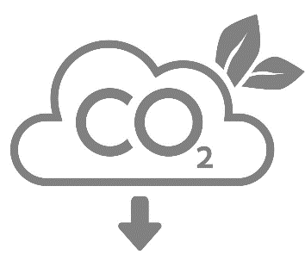
These solar systems were able to generate power for farms, that have either no connection to the national grid (electricity) or 3-4 hours of electric power generation by the grid. These systems provided uninterrupted power supply for 6-8 hours a day for the farms, generating enough power to operationalize the water pumps and the irrigation means (Sprinklers and Drip).
This significantly eradicated the usage of diesel power generators, leading to no CO2 emissions nor air pollution in the farms, also Increased Household Income.
Carbon Emission Reduction
1233 tCO2 per year

# | Governorate | Farms | Male owners | Female owners | Total
1 | Babil | 10 | 9 | 1 | 10
2 | Karbala | 10 | 9 | 1 | 10
3 | Najaf | 16 | 14 | 2 | 16
4 | Wasit | 15 | 14 | 1 | 15
5 | Qadisiya | 14 | 12 | 2 | 14
6 | Maysan | 20 | 16 | 4 | 20
7 | Dhi Qar | 16 | 13 | 3 | 16
8 | Basra | 15 | 10 | 5 | 15
 |  |  | 97 | 19 | 116

Sprinkler Irrigation Systems
- As indicated in our previous donor reports and verified by donor 3rd party monitoring A total of 77 sprinkler irrigation systems were fully installed and connected across the same 8 governorates.
- These systems are now fully operational and have contributed to:
  - More efficient water use
  - Higher crop yield, especially for water-sensitive crops
  - Expanded irrigation coverage for small and medium-scale farms.
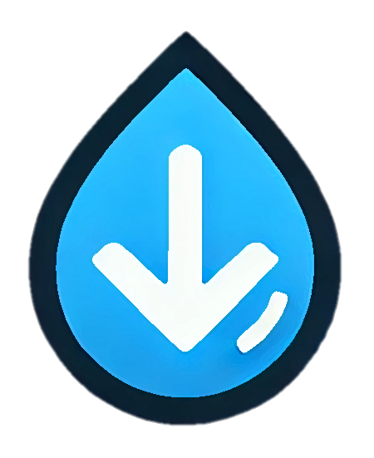
The irrigation systems—both sprinkler and pump-based—were deployed to support farms facing severe water management challenges, especially in areas with limited or irregular water flow. The systems enabled consistent and efficient water distribution, improving irrigation coverage and reducing water waste. By automating and optimizing water delivery, these solutions significantly decreased labor efforts, improved crop quality, and allowed farmers to diversify their cultivation. As a result, the farms experienced higher yields and better resilience to climate-related water stress. Moreover, the reduction in manual irrigation and the transition away from inefficient traditional methods contributed to increased productivity and higher household income for the beneficiary farmers.
Water Footprint Reduction
146 mil liters of water saved per year

# | Governorate | Farms | Male owners | Female owners
1 | Babil | 9 | 7 | 2
2 | Karbala | 14 | 14 | 0
3 | Najaf | 10 | 10 | 0
4 | Wasit | 6 | 4 | 2
5 | Dhi Qar | 9 | 7 | 2
6 | Maysan | 11 | 9 | 2
7 | Qadisiya | 8 | 8 | 0
8 | Basra | 10 | 8 | 2
 |  | 77 | 67 | 10

Irrigation Water Pumps
- As indicated in our previous donor reports and verified by the donor 3rd party monitoring,a total of 60 irrigation water pumps were supplied, installed, and are fully functional in 7 governorates: Babil, Najaf, Wasit, Qadisiya, Maysan, Dhi Qar, and Basra.
- These pumps provide steady and efficient water delivery, directly supporting:
  - Expanded cultivated areas
  - Reduced manual labor in irrigation
  - Improved timeliness and coverage of water distribution, especially in remote and underserved farmlands
# | Governorate | Farms | Male owners | Female owners | Total
1 | Babil | 9 | 7 | 2 | 9
2 | Karbala | 1 | 1 | 0 | 1
3 | Wasit | 4 | 3 | 1 | 4
4 | Qadisiya | 5 | 5 | 0 | 5
5 | Dhi Qar | 8 | 5 | 3 | 8
6 | Maysan | 3 | 0 | 3 | 3
7 | Basra | 30 | 24 | 6 | 30
 |  |  | 45 | 15 | 60

Capacity and Training sessions:
Comprehensive package of Climate and Renewable Energy trainings and capacity services to 152 youth individuals. A total of 6 group sessions for youth, The project supported the direct beneficiaries in skilling them on climate change and clean energy usage, youth groups were introduced to theoretical and practical capacity building on solar energy and were empowered to inter the renewable energy market in Iraq.
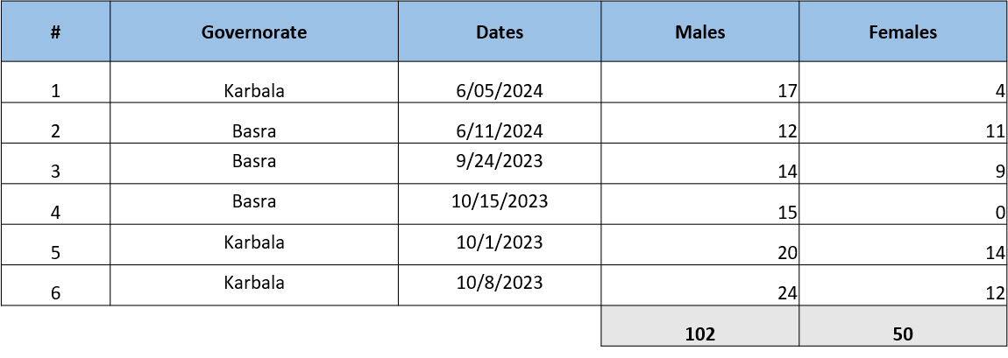

Advanced trainings scope was for existing MSMEs, to enhance their capacities on projects mapping, drafting, proposals and market assessment, as well marketing and promoting renewable energy projects.

# | Governorate | Dates | Males | Females
1 | Basra | 27 May 2024 | 20 | 5
2 | Karbala | 9 June 2024 | 22 | 3
 |  | 50 | 42 | 8

Main Topics Covered in the Youth Solar Energy Training Session
- Introduction to Solar Energy: Overview of solar systems and training objectives.
- Electrical Fundamentals: Voltage, current, resistance, Ohm’s Law, power factor, AC vs. DC.
- Solar Science Basics: Solar radiation, peak sun hours, sun positioning, shading, and site-specific factors.
- System Design & Components: Panels, strings, arrays, series/parallel wiring, diodes, reading datasheets.
- Installation & Operation: Inverter setup, wiring practices, safety, and mounting guidelines.
- Site Assessment: Shading analysis, area measurement, and placement of system components.
- Economic Considerations: Cost recovery, lifecycle cost, customer engagement, and system marketing.
- Energy Efficiency & National Grid: Rationalizing consumption and understanding Iraq’s power system.
- Awareness & Capacity Building: Public education through solar screens and youth/SME training in renewable energy.
Main Topics Covered in the advanced Business Skills for renewable energy (MSMEs)Training Session
- Entrepreneurship & Business Planning:
Developing, testing, and pitching renewable energy business ideas.
- Project Management:
Planning, structuring, scheduling, stakeholder engagement, and risk control.
- Leadership Skills:
Effective leadership styles and practical application in solar energy projects.
- Marketing & Compliance:
Marketing strategies and aligning with renewable energy standards.
- Grant Applications:
How to identify funding opportunities and write successful proposals.

Sustainable Land Management
As part of the project’s commitment to Sustainable Land Management (SLM), two advanced land laser leveler devices were delivered to the Water Directorates in Basra and Muthanna Governorates. These devices are critical tools in optimizing land leveling processes, reducing water runoff, and improving irrigation efficiency—thereby preventing land degradation and enhancing soil productivity. To ensure effective utilization and sustainability, technical training sessions were conducted for relevant stakeholders: in Basra on 7–8 October 2024, and in Muthanna on 9–10 October 2024. These trainings equip local technical teams from water user's associations heads, and department employees that have the knowledge to deal with large tools and machines, Trained beneficiaries were all males. and the farmers with the knowledge to operate and maintain the devices, promoting long-term adoption of climate-smart, resource-efficient agricultural practices.

Water Efficiency and sustainable water usage:
As part of its broader efforts to enhance water resource management and promote sustainable agriculture, the project implemented a strategic intervention along the Al-Aksa Water Canal in Najmi District, Al-Muthanna Governorate. The canal, which spans 7 kilometers, serves as a vital irrigation source for 91 large farms. Covering over 2700 dunums. Within this initiative, UNDP rehabilitated and solarized a 1.7 KM segment of the canal—representing over 45% of its total length—directly benefiting 31 farms and indirectly supporting all 91 farms.
The intervention included the paving of the canal’s surface, which significantly reduced water loss through evaporation, prevented salinization, and promoted water conservation. In parallel, solar-powered agricultural electric pumps were supplied, installed, and operated to ensure uninterrupted water flow and to improve irrigation efficiency. This integrated solution contributed to climate-smart water infrastructure, enhanced agricultural productivity, and ensured reliable access to irrigation for the farming communities.
The rehabilitated water canal was equipped with Flow Control Gates, Irrigation Regulators and other Canal Control Structures, to help optimize the water usage, and maintain a strong operation by the rules and regulation of the water directorate in AlMuthanna, with the use of water rationing.
To support sustainability, the project also provided training to local farmers and stakeholders on the operation of solar systems and water pumps.
- In addition to the technical and on ground vital support and services provided within the output 3 of the ICRRP project, the activities contributed to publicity and promotion for climate resilience and renewables as part of the climate action, supported by international community, in order to empower Iraq and the rural communities to adapt to the climate change and impacts on lands and livelihoods.
In this manner, a large campaign produced by UNDP and supported by USAID was accomplished listing various activities such as videos, photos, and carousels of eye friendly information on climate change, water scarcity and the impacts.
More than 1,000,000 users on combined platforms have been reached by the social media campaign of #MyGreenIraq

Human Interest Story
- A Brighter Future: Clean Energy Revives Farming in Southern Iraq (Karim Halel)

In the sun-scorched fields of Al-Lahis in Al-Zubair district, Karim Halel Al-Salhi, a 47-year-old farmer, recalls his childhood watching his father tend tomato crops in the 1980s. But decades later, what was once a fertile farming life faced collapse due to worsening drought, rising temperatures, and chronic power outages.

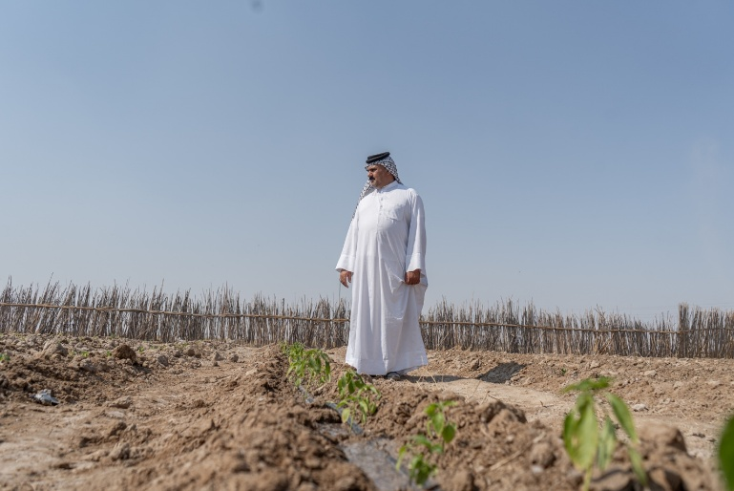
“Since I opened my eyes, I saw my father taking care of our land, as it was the sole providing to our family and home.”

“Hope returned when the UNDP stepped in,” Karim shares. With support from the United Nations Development Programme (UNDP) and USAID, Karim and fellow farmers received solar-powered irrigation systems and sprinklers—a transformative step toward sustainability. “Now, even during power cuts, the system kicks in immediately. No diesel, no smoke. It’s clean energy,” he says with pride.
The results were immediate and powerful. Water usage dropped drastically—from 30–40 tons to just 7–10 tons per cycle—thanks to efficient sprinkler systems covering over 65 wells. Soil quality improved, crop yields rose, and farming became more reliable and climate resilient.
Karim’s farm no longer depends solely on tomatoes. With modern irrigation, he expanded his crops to include wheat, barley, garlic, chili peppers, eggplants, onions, watermelons, melons, and okra. This shift is not just about agricultural diversification—it’s about resilience, adaptability, and renewed confidence in the future.

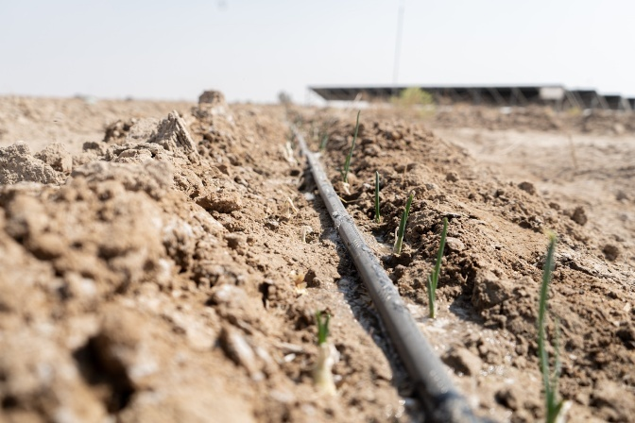
“This is more than a success story,” says Karim. “It’s proof that change is possible when farmers are equipped with the right tools and supported by committed partners.”

Through this initiative, 30 farmers in Basra, including three from Al-Zubair, are now leading the way toward environmentally friendly and sustainable farming, contributing to national food security while adapting to climate change.

- Reviving Hope Through Water: The Story of Al-Najmi’s Forgotten Canal

For years, the farmers of Al-Najmi District in Al-Muthanna Governorate stood in silence beside a once-thriving water canal, now reduced to a dry, crumbling trench. This canal had once nourished their lands, sustained their families, and kept the agricultural rhythm of the region alive. But seasons passed without planting, and fields lay barren under a burning sun. With every promise from visiting delegations or government missions, hope would rise—only to fall again.

“Every time a mission came through, we had our hopes high,” Hussein recalls. “But they always left… and so did our faith in seeing water flow again. When your team arrived, we had no hope.”
But this time was different.
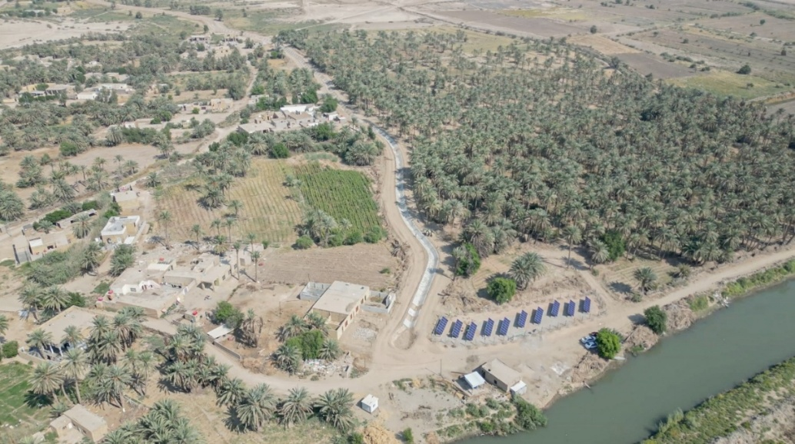

In partnership with the United Nations Development Programme (UNDP) and with the support of USAID, the long-abandoned canal finally saw signs of life. Concrete was laid. Machines roared to work. Solar pumps arrived. And the farmers of Al-Najmi watched in disbelief as their canal—after years of neglect—came back to life.

“We could not believe it. After so many years of loss, of watching our lands go dry, the idea that water would flow again seemed impossible. But then the work actually started… and didn’t stop.”

The project rehabilitated 1.67 kilometers of the canal, fully paved to reduce water loss from evaporation and prevent salinization. Solar-powered agricultural pumps were installed to ensure steady and sustainable water delivery. The change was immediate. Water returned, and with it, the sound of cultivation, the smell of tilled soil, and the rhythm of farming that had been missing for years.
For the farmers of Al-Najmi, this wasn’t just an infrastructure project. It was a restoration of dignity, livelihood, and trust. Now, with a functioning water canal, they are preparing their lands once more—for wheat, barley, vegetables, and fruits—and for a sustainable future they had almost given up on.

“It’s our life coming back.”

Cross-cutting issues

Gender results

Empowering Women through Output Three of the ICRRP,
A significant achievement under Output 3 was the targeted support to women-owned farms. In line with the output’s wholistic priority to empower vulnerable communities—with women as a central focus—the project ensured intentional gender inclusion at every stage.
Across all interventions detailed in this report, no less than 35% of total beneficiaries were women, demonstrating a consistent and structured approach to gender-responsive programming.
- 20 women farm owners directly benefited from the installation of solar-powered irrigation systems and water pumps, significantly reducing their dependence on costly, fuel-based technologies and enhancing their farm productivity and resilience.
- 50 women participants successfully completed foundational training on solar and renewable energy, equipping them with important knowledge and confidence to participate in the green economy.
- 8 women entrepreneurs or business managers engaged in advanced business and technical training for solar and renewable energy enterprises, improving their capacity to scale, lead, and sustain clean energy ventures.
The project catalyzed tangible changes in the work lives of the participating women:
For women farmers, the transition to solar-powered irrigation enhanced their economic independence, reducing labor burden, and increased yields—empowering them to reinvest in their farms and family livelihoods.
Women trained in solar technologies reported increased confidence to work in male-dominated sectors, and some initiated income-generating activities by servicing or selling solar components within their communities.
The advanced training cohort of women entrepreneurs is now better positioned to lead clean energy enterprises, contributing to job creation and the expansion of gender-inclusive green markets in rural and urban areas.
Woman inclusion not only strengthened the project's sustainability but also actively contributing to the shift in mentality for the communities, and enhancing women participation in society, contributing to a broader transformation in how women engage with climate-resilient technologies and the energy sector.

Partnerships

The output worked closely with the government counterparts in Ministry of Agriculture and Ministry of Water Resources and their directorates in the 8 governorates of the mid and south of Iraq. Also the project worked closely with the Agricultural and Water Resources departments per districts.
The implementation was able to work with no less than 30 entities from the government,
As well the out was able to work with Water Users Associations (CSOs) in Basra, Muthanna, Karbala and the rest of the governorates… Additionally the implementation were able to engage with the Water Users Association with equipping them with Land Laser Levelers in Basra and Muthanna.

The output implementation was contracted to existing private sector to deliver the output of the activities under this output. It was able to work with several private sector companies via contractual agreements, of no less than 14 entity, aside from the training and capacity building the output was able to deliver in the advance stage, for MSMEs.

The Government entity was an assisting partner, were it was facilitated to identify the farms and the supervision of the implementation of the activities, as well all the handovers.
This been said the government was a strong partner and facilitator to ensure the delivery of the activities, aside from the encountered delays.

Environmental Considerations

The output speaks to the environmental resilience. It was planned to assist livelihoods and promote disaster risk reduction, as well introducing energy and resource access for the beneficiaries. Thus the output had a direct consideration with the environmental consideration and responsibilities.
All the technologies used under the implementation was environmental friendly, as well smart technologies for Agriculture.

Monitoring and evaluation were taking part by the engineers contracted under the output, to assess and observe, as well to communicate the environmental adherence to the implementing bodies, in addition to the close monitoring and follow up of the project team.
The output mainly speaking to the sustainability of its supplied tools, as the main source of the energy is renewable energy, as well supplies were guaranteed for a year after installation,
Additionally, beneficiaries were supported by workshops that linked them to the suppliers, to have a strong linkage and understanding of how to have reach out after the project ends.

Project risks and issues

Project risks and challenges
The implementation of this output proved more complex than anticipated due to the fluctuating water rationing across different irrigation outlets, presenting challenges in finalizing beneficiary lists, identifying suitable buildings, and specifying the solar-powered irrigation systems.
The selection of beneficiaries was contingent upon farmers’ willingness to adopt photovoltaic (PV)-powered irrigation systems. Initially, this included a cost-sharing requirement, which was subsequently waived. Furthermore, eligibility required legal endorsements from both the Ministry of Agriculture and the Ministry of Water Resources. The Ministry of Water Resources is responsible for allocating legal water shares, overseeing registered farm contracts, and verifying land ownership. Meanwhile, the Ministry of Agriculture oversees agricultural entitlements related to crop and seed distribution, as well as aspects of marketing and value chain development. This been said, no selection is possible without the full coordination and initial selection by the ministries resulting in delays due to coordination with multiple ministries and verification by local governorate staff. The selection process was carefully structured to align with the objectives of the project output and to match the capacities of both the proposed activities and the selected farms. As such, a comprehensive set of selection criteria was developed (refer to Annex 1), which served as a guiding framework to ensure effective and appropriate implementation by the project team.
Efforts were made to avoid lower quality solar panels by specifying pragmatic requirements for Iraq, leading to prolonged procurement proceedings for the solar-powered irrigation systems. This necessitated many steps, consultations, specifications, longer procurement process to ensure quality and compliance as applicable.
Despite encountering delays from government entities and procurement processes, the project team's dedication, strategic partnerships with USAID, and stakeholder collaboration facilitated progress. Moving forward, sustaining momentum is crucial to capitalize on achievements, extending benefits beyond clean energy to impact youth, micro, small, and medium enterprises (MSMEs), and communities in targeted governorates. This output lays the groundwork for renewable energy adoption and improved irrigation practices, contributing to Iraq's sustainable development goals.
Furthermore, the output serves as a model for broader government initiatives, emphasizing the transition from fossil fuels to renewable energy sources, reducing greenhouse gas emissions, power and water consumption, and associated costs. The ICRRP-RE exemplifies the potential for large-scale adoption of similar measures, fostering a robust movement towards sustainable energy practices in Iraq.

Identified Risk | Mitigation Measure | Effectiveness of Mitigation
Fluctuating water rationing across irrigation outlets affecting implementation | Worked closely with Ministry of Water Resources to prioritize stable areas and aligned project design accordingly | Partially effective some fluctuations persisted, but critical implementation areas were secured
Risk of installing low-quality solar panels due to limited local standards | Developed pragmatic technical specifications tailored to Iraq context to ensure minimum quality standards | Effective procurement delays were experienced, but high-quality systems were delivered
Delay in procurement due to technical specifications and approvals | Conducted extensive consultations and technical reviews to align specifications before procurement | Moderately effective improved quality assurance but increased lead time in procurement

Challenges | Action Taken | Effectiveness of Action
Difficulty in finalizing beneficiary lists due to water and land entitlements | Developed comprehensive selection criteria and worked with local directorates for verification | Effective allowed fair and structured beneficiary selection based on verified entitlements
Coordination bottlenecks between Ministry of Agriculture and Ministry of Water Resources | Established inter-ministerial coordination protocols and involved local governorate staff in early verification | Moderately effective coordination improved but verification caused delays
ToRs and Procurement  Approval Delays for ToRs and Procurement  Significant delays in approvals of ToRs for solar and irrigation experts.  Delays in procurement due to donor criteria (e.g., product origin restrictions). | Solar experts were eventually hired and extended to maintain implementation timelines.  Irrigation experts planned for rapid recruitment once approvals were received.  Eventual Waiver signature from USAID to accept different sources of origin for supplies. | Highly effective, but time consuming.
Media Campaign Direction Changes  USAID requested major changes in the campaign scope (from solar-specific to general environmental topics), leading to content revisions and delays. | Responsive Media Adjustments  Communication materials and CNs were revised multiple times based on donor feedback.  New direction taken to focus on broader environmental topics, with ongoing donor coordination, also result ordinated media campaigns to focus on services delivery within the scope. | Highly effective, but time consuming.

Lessons Learned
The implementation of Output 3 of the ICRRP offered numerous insights into renewable energy deployment, stakeholder coordination, and sustainable water management within vulnerable farming communities in Iraq. The following lessons were drawn from the program’s achievements, challenges, and field experiences:
- Integrated Planning and Flexibility are Crucial for Complex Multi-Sector Projects
Coordinating with multiple ministries (e.g., MoAgr, MoWR), donors, local authorities, and communities proved critical but time-consuming. The project learned that a parallel verification process and adaptive beneficiary selection mechanisms were essential in overcoming bureaucratic delays and fluctuating field conditions.
Lesson:
- Establishing parallel pathways for implementation and verification (e.g., through site engineers and joint coordination units) enhances responsiveness and adaptability in multi-stakeholder projects.
- Strengthening the coordination and cooperation with the governmental entities, via regular meetings, orientation, full project knowledge, and most importantly engagement of the entities from day 1 of the project.
- Ownership of the GoI, the sense of ownership it very crucial for the government to give the momentum for the government to be the first to push.

- Stakeholder Ownership and Engagement Strengthen Sustainability
Engaging farmers, local water user associations, and provincial water directorates throughout planning, training, and execution stages contributed to sustained use of technologies, especially solar-powered irrigation and canal rehabilitation.
Lesson:
- Early and continuous engagement of local stakeholders builds ownership and significantly increases the long-term success and sustainability of infrastructure and energy interventions.

- Site-Specific Solutions Maximize Impact
The application of laser land levelling in Basra and Muthanna, closed-pipe irrigation in Karbala, and canal rehabilitation in Al-Muthanna highlighted that one-size-fits-all solutions are not always effective. Customization based on agroecological needs and water availability was vital.
Lesson:
- Tailoring technical solutions to local environmental and socio-economic conditions ensures greater efficiency, relevance, and impact.
- The piloting on different measures and techniques are highly important to sow case lessons learned and success of projects, and also to map what are the most successful climate resilient solutions to fit to Iraq and help optimize the most, resulting in high success and good utilization of resources and efficient management.
- Clean Energy Can Drive Economic Inclusion
Installing 116 for individual farms solar-powered irrigation systems and modern irrigation mechanisms significantly reduced operational costs and improved productivity. This, in turn, led to an average increase of 20% in crop yields and annual savings of up to $4,500 per household.
Lesson:
- Clean energy deployment is not just an environmental solution—it is a catalyst for income generation, poverty reduction, and economic empowerment of rural communities.
- Utilizing resources, and enhancing resource management is vital, especially in rural areas, when communities is suffering from power deprivation.
- Implementing more off-grid pilot initiative, that will lead to no load on national grid.

- Conflict Sensitivity and Local Mediation Are Essential in Collective Resource Management
The rehabilitation of the Al-Aksha canal initially faced conflicts among farmers due to competing water interests and lack of coordination. The creation of a local liaison committee helped manage risks and promote collective decision-making.
Lesson:
- Projects operating in shared-resource settings must adopt conflict-sensitive approaches, including community-led committees for mediation and joint planning.

- Procurement Challenges Can Be Mitigated Through Early Planning and Donor Engagement
The project experienced procurement delays due to USAID requirements on the origin of goods and local market limitations. However, proactive donor engagement and a waiver request process helped resolve these issues.
Lesson:
- Timely dialogue with donors and early market analysis are essential to anticipate and navigate procurement constraints in development settings.

- Media Campaigns Require Aligned Branding and Donor Direction
Midway through implementation, the project's media strategy had to be significantly revised to reflect broader environmental narratives instead of a narrow focus on solar energy. This caused delays in publication and outreach.
Lesson:
- Communication and visibility plans should remain flexible and include provisions for rapid content adaptation to reflect donor branding and evolving strategic directions.

- Youth and MSME’s Capacity Development Requires Long-Term Support
While training sessions reached 152 youth and 50 MSMEs, the sustainability of their engagement in the renewable energy sector depends on follow-up mentorship, financing opportunities, and market integration.
Lesson:
- Capacity-building efforts for youth and MSMEs should be complemented by access to finance, technical mentorship, and market access support to ensure long-term impact.

Conclusions and Way Forward
As Output 3 of the Iraq Crisis Response and Resilience Programme (ICRRP) reaches its conclusion, a comprehensive closure and sustainability framework has been adopted to ensure continuity, local ownership, and long-term impact.

Summary of Main Deliverables and Impacts
Output 3 has successfully delivered tangible, climate-resilient solutions that directly benefit vulnerable farming communities and local economies across target governorates:
- 116 solar-powered irrigation systems installed and operational, reducing reliance on fossil fuels and lowering energy costs.
- 77 sprinkler irrigation systems deployed, enhancing water-use efficiency and crop productivity.
- 60 water pumps were installed to improve irrigation access and agricultural output.
- Two land laser levelers delivered, and training provided, improving land efficiency and water distribution.
- Two solar-powered awareness screens installed for public education on sustainability.
- 152 youth trained in renewable energy and 50 MSMEs supported through technical and business development training.
- One major water canal rehabilitated, restoring irrigation infrastructure for farming communities

Strategic Relevance to National Priorities and CPD
Output 3 directly supports Iraq’s national priorities on climate adaptation, sustainable agriculture, and rural development. The interventions align with:
- Iraq’s Nationally Determined Contributions (NDCs), particularly adaptation in the agriculture and water sectors;
- The National Framework for Climate Resilience, addressing energy access and water scarcity;
- The UNDP Country Programme Document (CPD), which promotes community stabilization, inclusive growth, and environmental sustainability.
These outcomes contribute to building long-term resilience and socioeconomic empowerment for rural populations, especially in crisis-affected areas.

Project Closure and Implications for Continuity
With the formal closure of Output 3, implementation activities have ceased. While most physical and capacity-building deliverables have been achieved, some longer-term targets—such as scaling up interventions, institutionalizing maintenance mechanisms, and deeper market linkages—may require continued support.
The premature stop of the project limits its ability to further consolidate gains or expand into additional communities. UNDP remains committed to advocating for further resource mobilization and integration of the model into government rural development frameworks to sustain and expand these efforts.

Sustainability and Local Ownership
To ensure continuity:
- All systems (solar irrigation, pumps, sprinklers) have been officially handed over to farmers under the supervision of the Directorates of Water and Agriculture.
- Handover packages included technical manuals and documentation to guide local maintenance and ensure self-reliance.
- Water User Associations and local authorities have been actively engaged to foster community-based governance and support.

Capacity Building and Private Sector Linkages
- Farmers, youth, and MSMEs have received hands-on training in operating renewable energy systems and irrigation techniques.
- MSMEs were connected with suppliers and beneficiaries through dedicated workshops to foster long-term maintenance services and introduce market-ready technical portfolios for future upgrades.

Monitoring and Evaluation (M&E)
Monitoring mechanisms were implemented throughout the project lifecycle to track progress, assess quality, and ensure accountability:
- UNDP applied field-level monitoring tools (checklists, site inspections, beneficiary interviews) in coordination with local authorities.
- The donor (USAID) conducted periodic reviews, field visits, and third-party verifications to validate progress and ensure compliance with quality standards.

Lessons learned and feedback loops were integrated into implementation, allowing for mid-course adjustments and improved delivery.Knowledge Sharing and Visibility
Key learnings, human impact stories, and visual documentation are being compiled into final reports and outreach content (e.g., #MyGreenIraq) to showcase achievements and inspire replication. This material will also inform future programming and policy engagement with national stakeholders and development partners.

Financial Status

The financial status until 17 June 2025, was as below:
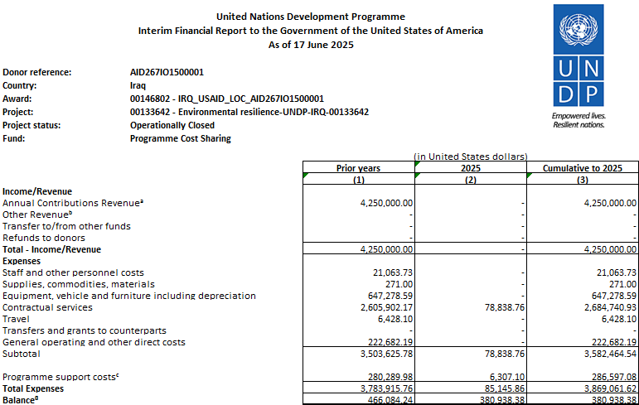

- Annex

Annex 1 Farms Criteria:
Eligibility Criteria Summary for Farm Selection
- Location & Legal Status
  - Farms must be located in one of the targeted governorates (Mid Euphrates or southern Governorates).
  - Legal documentation must be provided (ownership or lease contract).
  - Farms must be officially registered with valid plot and section numbers.
- Water Access & Irrigation
  - The farm must have an existing water source (well, river, or other).
  - Information about the method of irrigation (surface, drip, sprinkler) and water quality (fresh, saline, polluted) must be available.
  - Willingness and ability to establish or already have a water tank for night-time irrigation if solar energy is not stored.
- Energy Access & Needs
  - Availability of electricity sources (national grid or generator), including the number of hours accessible daily.
  - Type, number, and capacity of existing water pumps.
  - Willingness to operate pumps during peak solar hours and adopt solar power.
- Agricultural Activity
  - Active cultivation of crops (wheat, barley, vegetables, fruits, etc.).
  - Proof that the land was actively used in the last season (not abandoned).
  - Willingness to engage in solar irrigation to sustain or improve productivity.
- Economic & Social Aspects
  - Ability to cover 40% of the solar system cost (initial requirement), or explain financial alternatives (personal savings, bank loan, etc.). / This was later removed due to the mentioned reasons.
  - Number of family members and laborers working on the farm.
  - Commitment to maintain the system post-installation.
- Technical Verification
  - Site verification and GPS coordinates.
  - Assessment by field engineers on water quality, pump capacity, and feasibility of solar system installation.
  - Evaluation of the impact potential on cost savings and emission reductions.
- Governmental Oversight
  - Coordination and approval from the Ministry of Agriculture and Ministry of Water Resources.
  - Assessment alignment with water share rights and agricultural support systems.

Annex 2 USAID Project Indicators:

Category | Indicator | Type of Indicator | Achievement to Dec 2024
Output | EG.12-2 Number of institutions with improved capacity to address clean energy issues as supported by USG assistance | Standard | 50
Output | 1. Private sector (including MSMEs) | Standard | 50
Output | 2. CSOs | Standard | 9/ Water Users Associations
Output | 3. Farmers | Standard | 830
Output | 4. Government institute | Standard | 30
Output | EG.12-7 Projected greenhouse gas emissions reduced or avoided from adopted laws, policies, regulations, or technologies related to clean energy as supported by USG assistance | Standard | 1,233 tons of CO2
Output | YOUTH-3 Percentage of participants who are youth (15-29) in USG-assisted programs designed to increase access to productive economic resources [IM-level] | Standard | 152
Outcome | Amount of reserved water as a result of innovative solution and best practices of the project intervention in letter | Custom | 146 mil liters
Outcome | Amount of produced clean energy supported by USAID in KW. | Custom | 2,530 KW
Outcome | ● KW | Custom | 2,530 KW
Outcome | ● Province | Custom | 9 governorate
Outcome | EG.11.2 Number of institutions with improved capacity to assess or address climate change risks supported by USG assistance | Standard | 60
Outcome | EG.5-15 Percentage change in sales of firms receiving USG-funded assistance | Standard / Quarter | 40%
Outcome | EG.12-4 Amount of investment mobilized (in USD) for clean energy as supported by USG assistance | Standard / Quarter
Outcome | PSE-3 Number of private sector enterprises with improved participation in the local economy as a result of USG assistance | Standard / Quarter | 30
Activities | Indicator 7: # of persons who received awareness raising messages on renewable energy from social media | Custom | 2 M
Activities | Indicator 6: # of persons who received awareness raising messages from the two building annually | Custom | minimum 40K
Activities | Indicator 5: # of buildings/facilities equipped with solar energy for awareness raising | Custom | 2
Activities | Indicator 4: # of people who received training on solar energy marketing, management, sales and services  I. Basic training  II. Advanced training  III. Gender | Custom | I. Basic training: 152  II. Advanced training: 50  III. Gender: 25% Basic, 10% Advance FEMALE Basic: 38 Advance: 9

Annex 3: Advocacy, Media and Promotion:
Product |  | Delivery | Links
1 | Video - Aksha | Filmed not published due to termination of fund and completion of the activity was terminated.
2 | Video – Solar (during 1) | Delivered and Published Basra #2 | UNDP Iraq | ‎. تتعاون الوكالة الامريكية للتنمية الدولية وبرنامج الامم المتحدة الإنمائي في العراق لتمكين المزارعين في قضاء الزبير بمحافظة البصرة من خلال...‎ | Instagram
3 | Video – Solar (during 2) | Delivered and Published Karbala #1 | UNDP Iraq | ‎. يتعاون برنامج الأمم المتحدة الإنمائي والوكالة الأمريكية للتنمية الدولية لتعزيز الإدارة المستدامة للموارد ومعالجة آثار التغير المناخي في...‎ | Instagram
4 | Video – Water Efficiency & Solar | Delivered and Published Basra #1 | UNDP Iraq | ‎. في #البصرة، يعمل برنامج الأمم المتحدة الإنمائي والوكالة الأمريكية للتنمية الدولية معاً على تعزيز إدارة الموارد المستدامة ومعالجة آثار...‎ | Instagram
5 | Activity – Trip to Marshlands | Canceled due to safety concerns from donor on students.
6 | Activity – Interview | Delivered and Published | UNDP Iraq | ‎اليوم العالمي للبيئة: حديث مع الدكتور عمر الشيخلي تحدثنا مع الدكتور عمر الشيخلي عن أهم التحديات البيئية التي تواجه العراق وكيفية التصدي...‎ | Instagram
7 | Info – Modern Irrigation Methods | Delivered and Published | UNDP Iraq | ‎‎ما هي طرق الري الحديثة؟ وما هي فوائدها؟ اقرأوا كيف يقوم برنامج الأمم المتحدة الإنمائي، بالتعاون مع الوكالة الأمريكية للتنمية الدولية،...‎ | Instagram
8 | Info – Climate-induced Migration | Delivered and published | UNDP Iraq | ‎. الهجرة الناجمة عن التغير المناخي هي أزمة متنامية في العراق، مع إرتفاع تأثيرات #التغير_المناخي كل عام. ومع تزايد أنماط النزوح، يكثف برنامج...‎ | Instagram
9 | Info – Crops Diversification | Delivered and published | UNDP Iraq | ‎. يتعاون برنامج الأمم المتحدة الإنمائي والوكالة الامريكية للتنمية الدولية في العراق لتعزيز أدارة الموارد ومعالجة أثار التغيير المنا في وسط...‎ | Instagram
10 | Video – Marshes Cartoon | Delivered and published | UNDP Iraq | ‎إن أهوار بلاد ما بين النهرين هي جزء أساسي من تراثنا العراقي. لكنها باتت تجف بسرعة بسبب شحة المياه وارتفاع دراجة الحرارة الشديد التي يسببها...‎ | Instagram
11 | Interview – Fatimah Zayer (Marshland) | Delivered and published | UNDP Iraq | ‎ترقبوا غداً لقاءنا الكامل مع "زائرة فاطمة" ابنة الأهوار. Stay tuned for our full interview with Zayra Fatimah tomorrow. #USAID_UNDP...‎ | Instagram
12 | Video - drought in the south | Delivered and published | UNDP Iraq | ‎. سيد رعد هو أول فرد من عائلته منذ اجيال يواجه جفاف بهذه الشدة في #أهوار جنوب العراق. على الرغم من ان الأهوار التي يتذكرها كانت زاخرة...‎ | Instagram
13 | Photo Album – International Interest on the Project | Delivered and published | UNDP Iraq | ‎🌱 تعزيز الزراعة المستدامة في #البصرة. 🌱 التقى نائب الممثل المقيم لبرنامج الأمم المتحدة الإنمائي في العراق، ساشا غرومان، بالسفيرة الهولندية...‎ | Instagram

Iraqi Government and FAO Launch $39-Million Climate Resilience Project
Iraq's central bank promotes climate finance
Reevaluating And Realigning United States Foreign Aid – The White House
Iraq’s Power Sector: Problems and Prospects - Georgetown Journal of International Affairs
The target was later revisited to fall into 2 categories (MSMEs and Youth as in the total achievement.
Disclaimer: Data contained in this financial report section is an extract of UNDP financial records. All financial provided above is provisional.

